**Assignment 12**

Case study of any one mobile analytics tool

**Author**

Name: Sakshi Tantak

Class: TE-9

Batch: M-9

Roll No: 33156

**Detailed description of the tool**

Tool used: AppFigures API Tool

Appfigures is a reporting platform for mobile app developers that brings together all of your app store sales, ad data, worldwide reviews, and hourly rank updates into one intuitive and informative reporting solution. It is popularly and widely used as a mobile analytics tool by more than 1,50,000 companies worldwide ranging from OneSignal, Airbnb to Trello and Snapchat.

They essentially provide multiple services related to mobile app analytics and reporting such as the following:

1. Performance Analytics
2. App Store Optimization
3. Automatic review collection and translation
4. Rank Monitoring
5. App Market Intelligence
6. Sales prospecting

**1.Performance Analytics**

### Full coverage across every store

They bring together and normalize all your revenue numbers, usage metrics, market performance figures, and user feedback from every market.

1. See your true bottom line

They intelligently sum all your revenue sources including app downloads, sales, in-app-purchases, subscriptions, and ads to provide 100% accurate revenue reports and payout tables.

1. Put your data to work

Looking to compare your sales with app store page views? Subscription conversions vs. ranks? You can do that and so much more with their flexible reports and extensive data sets.

1. Hourly app ranks

Discover trends and see how all the apps you track are doing right now. Overlay rankings with other data sets to get even deeper insights.

1. Practical top app lists

View the top 400 apps in every store instantly. Jump across countries and categories with one click, watch specific apps, and compare lists side-by-side.

1. Indispensable email reports

Your revenue figures, usage stats, and user feedback are delivered to your inbox daily or weekly. Easily set up custom reports for anyone on your team.

1. Real time alerts

They will let you know as soon as something interesting happens with any of your apps. Set up a general alert or specify custom filters that fit your team's unique workflow. They speak email, slack, push notifications, and more.

1. Convenient Integrations

Quickly connect your Appfigures data with your other business tools via their handy integrations, or go to the source with our rich and open API.

**2. App Store Optimization**

1. Keyword Research

Successful ASO requires optimizing for the right keywords. Appfigures takes the hassle and guesswork out of finding new keywords with smart suggestions, all based on data they collect from the App Store and Google Play every hour and analyze with their proprietary performance algorithm.

1. Competitor Analysis

Find out how your competitors are doing in search results in comparison to your app quickly, and uncover keywords they're using in different countries and devices around the world.

1. Keyword Analysis

Analyze the current search results for any keyword across countries, stores, and devices with accurate download estimates, ranks, ratings, and other metrics stores use to rank apps so you can quickly tell if you can compete in a keyword.

1. Rank Tracking

Track keyword rank trends for your app and your competitors across the App Store and Google Play all around the world with hourly rank updates. Stay up to date with keyword rank change alerts sent directly to your inbox or Slack.

1. Keyword Discovery

Most apps are ranked in more keywords than they optimize for. With Appfigures, you can quickly discover where your apps are ranked in different countries. Use those keywords to build up momentum, and since they update every hour, you'll always be ahead of your competitors.

**3. Automatic review collection and translation**

1. Alerts for new reviews

Get new reviews right to your inbox, Slack, or to your mobile device.

1. Search and filter all reviews

Find actionable reviews quickly with filters and keyword search.

1. Reply to reviews directly

Reply to your reviews without leaving the platform. Just type and submit.

1. Share your reviews

We turn every review into a beautiful page you can easily share with anyone.

**4.Rank Monitoring**

1. See Where Any App is Ranked at a Glance

Get a top-level view of any app's performance across all countries and categories in a single report. Size up apps quickly and identify opportunities effortlessly.

1. Get the Full Picture with Complete Historic Data

Dig into granular history of every app to identify trends and size up growth. Go back to day one, analyze the last 30 days, or specify any other time period. There are no limits.

1. Browse Every Top Chart

App stores change rapidly. See the Top App lists in every country and category across major app stores easily and take advantage of opportunities before anyone else with deep coverage and hourly updates.

1. Extend with Intelligence Data

Go beyond ranks to get a deeper understanding of any app and category performance with their proprietary intelligence data. Choose from download and revenue estimates, audience demographics, ad spend, and installed technologies.

**5.App Market Intelligence**

1. Comprehensive Filters

Explorer's powerful search engine lets you identify apps with a variety of filters — from name and price, to SDKs, demographics, performance, and more.

1. Flexible Queries

Combine filters using AND/OR operators to build complex queries and to zoom in with great precision to identify the apps you need.

1. Customizable Results

Customize the results view to show the columns you care about most. From the basics, to monetization, or any other combination.

1. Mobile SDKs & Permissions

View and filter by the most accurate list of technologies used by every app, including SDKs, permissions, and capabilities.

1. Store Data

From pricing and monetization strategy to similar apps, developer locations, and much more. Explorer's profiles show you every detail.

1. Demographics

Pinpoint your targeting and uncover unique insights about any app's user-base with gender and age demographics.

**Costing**

The Appfigures API offers programmatic access to a wealth of data, from app performance to store performance and metadata.

Everyone with an Appfigures account can use the API to access data on apps they track for free. The same data that’s available in their Appfigures reports will also be available through the API.

There are several use-cases that are not free:

1. App Lookup and Getting Data for Apps You're Not Tracking

The Appfigures API provides access to all apps, including a powerful search for apps by metadata. With it you can find apps, get their ratings and ranks, see where they’re featured, read their reviews, and much more.

Accessing data for apps that aren’t tracked in your account is billed with credits, where every request cost one or more credits and credits are purchased in packages.

If a request requires credits and you don’t have any in your account you will get a response that specifies that credits are necessary and how many.

You can purchase credit packages for as low as $0.01/credit by enabling the Public Data API Add-on. There you can also set up automatic addition of credits.

1. More than 1,000 Requests/Day

By default, all accounts can make up to 1,000 requests to the API in a given day. You can increase this limit by going into Account settings -> API and selecting a limit that suits your needs.

1. Data Processors and Resellers

The Appfigures API can be used by any member internally, but to use it to resell App Store data you’ll need a partnership agreement.

**Discussion about output/outcome**

Mobile Analytics can only be done on an application that we own. As no one owned an application as such, we applied mobile analytics to an “example app” called ‘Retro Game’ by Google.

We got the following outputs for the same:

1. **Dashboard**

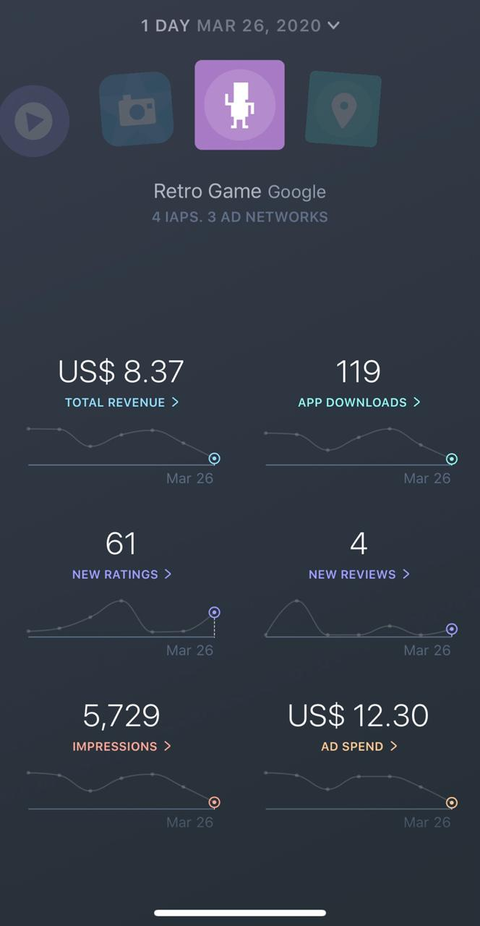

1. **Downloads**

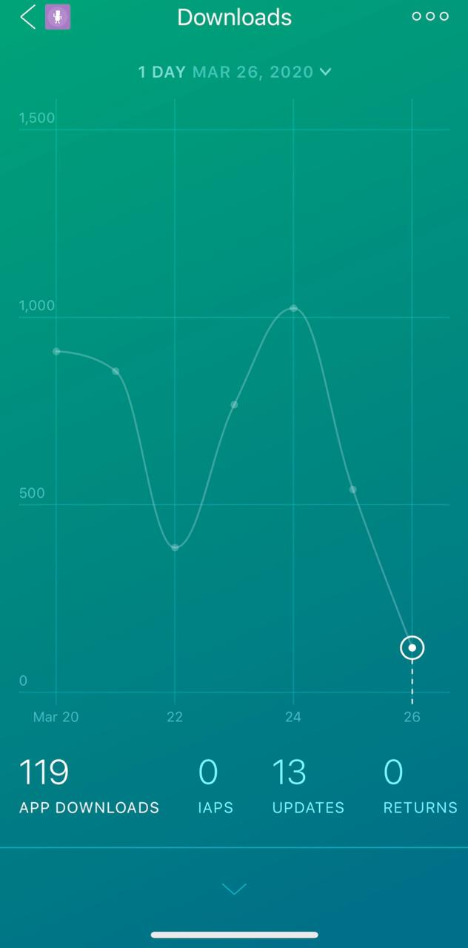

1. **Reviews**

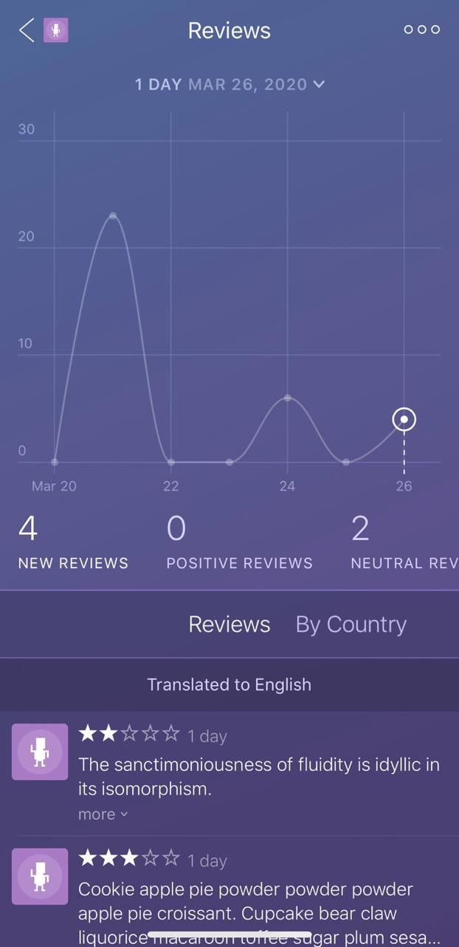

1. **Revenue**

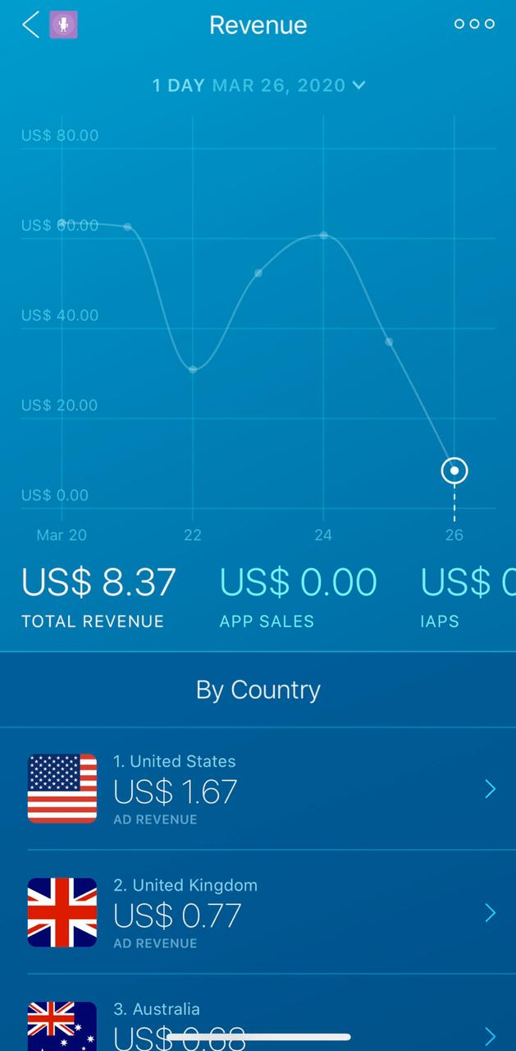

1. **New negative ratings trend**

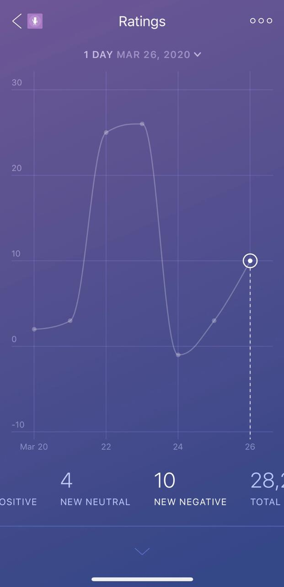

1. **New positive ratings trend**

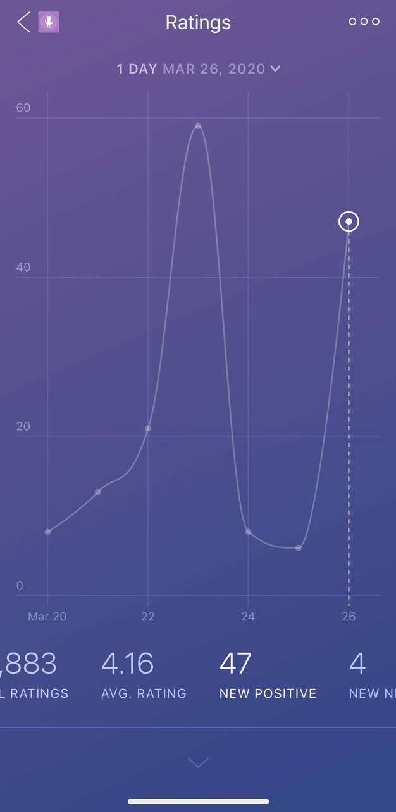

1. **New neutral ratings trend**

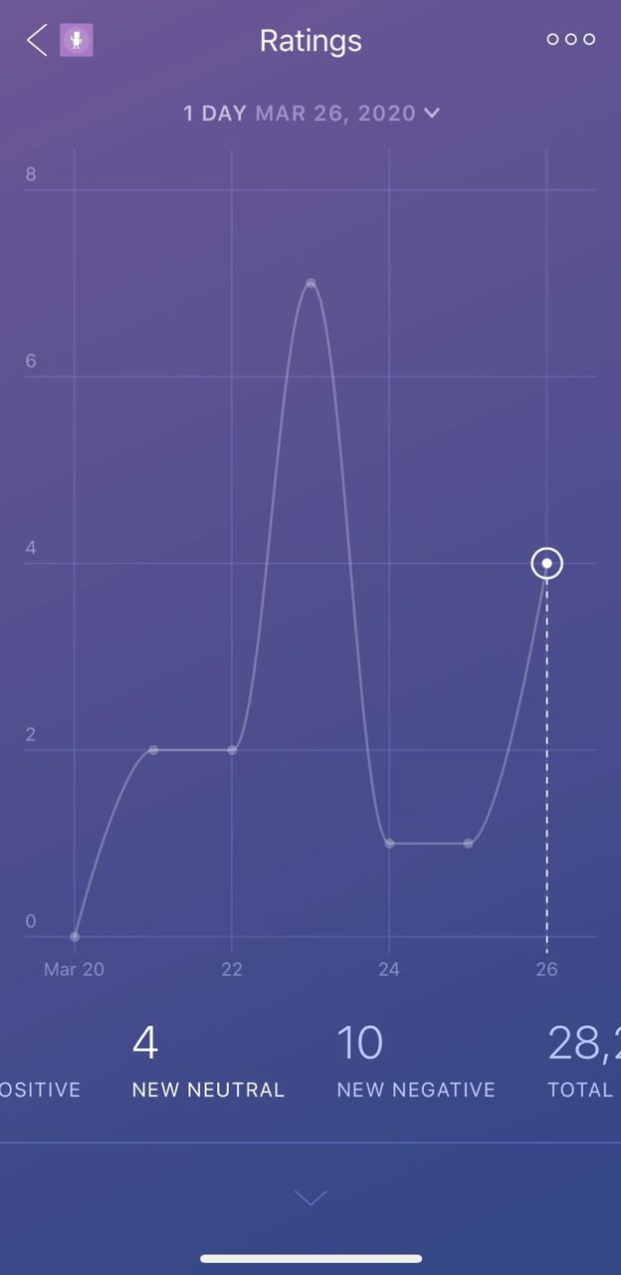

**Conclusion**: Thus, the required mobile analytics by using a mobile analytics tool has been successfully carried out.